**Enable Query Store on a Database – SQL Server 2016**

**Here we will see how can we enable it on a Database:**

**–>** Right click on the Database you want to enable Query Store and select Properties. Now select the new feature Query Store at the bottom left side as shown below:

[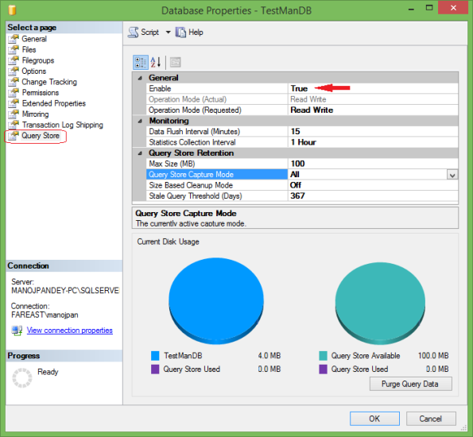](https://sqlwithmanoj.files.wordpress.com/2015/05/sql-server-2016-query-store-01.png)

Set the **Enable** option to **True**, and click OK.

**–> Alternative:** You can also enable the Query Store by this simple **ALTER DATABASE** Statement:

|  |  |
| --- | --- |
| 1  2  3  4  5 | USE [TestManDB]  GO    ALTER DATABASE [TestManDB] SET QUERY_STORE = ON  GO |

**–>** After enabling the Query Store you can check the Database, expand it in Object Explorer, you will see a new folder with the same name “Query Store”, on expanding it you will see 4 reports, as shown in below snapshot:  
[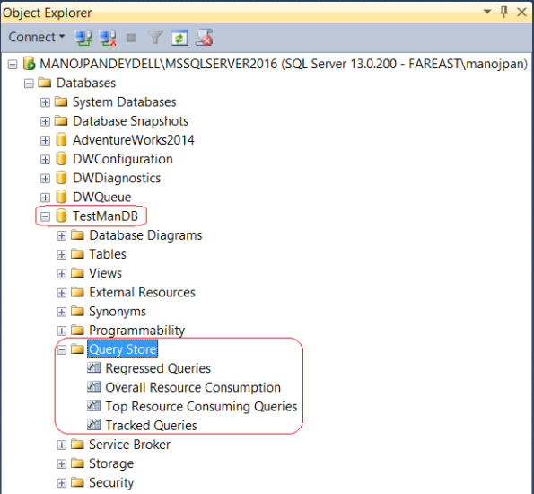](https://sqlwithmanoj.files.wordpress.com/2015/06/sql-server-2016-query-store-02.png)